0: https://admin.sdlian.cn/l/euZXlyWg0D

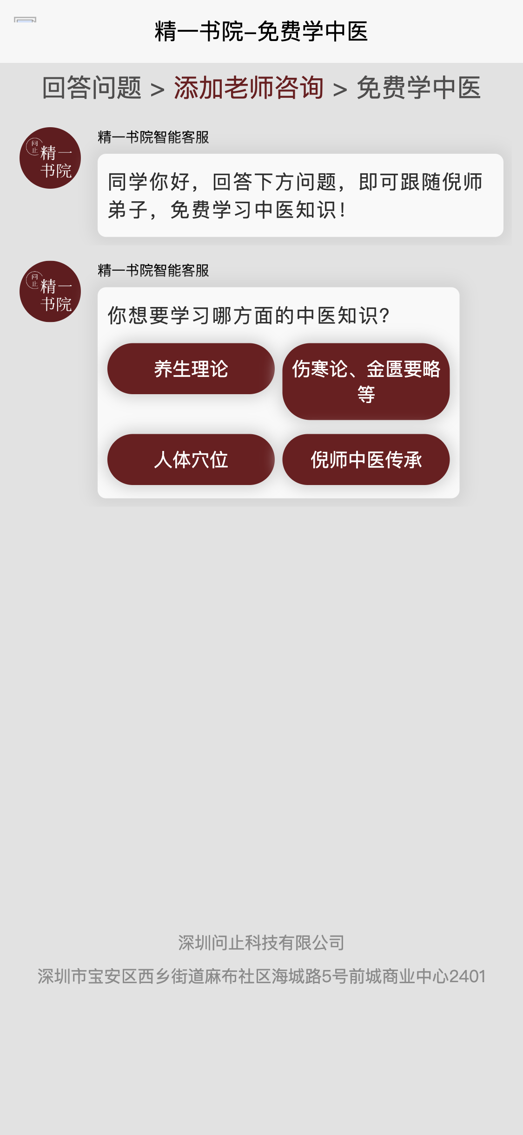

1: https://admin.sdlian.cn/l/P1BcIrVvvG

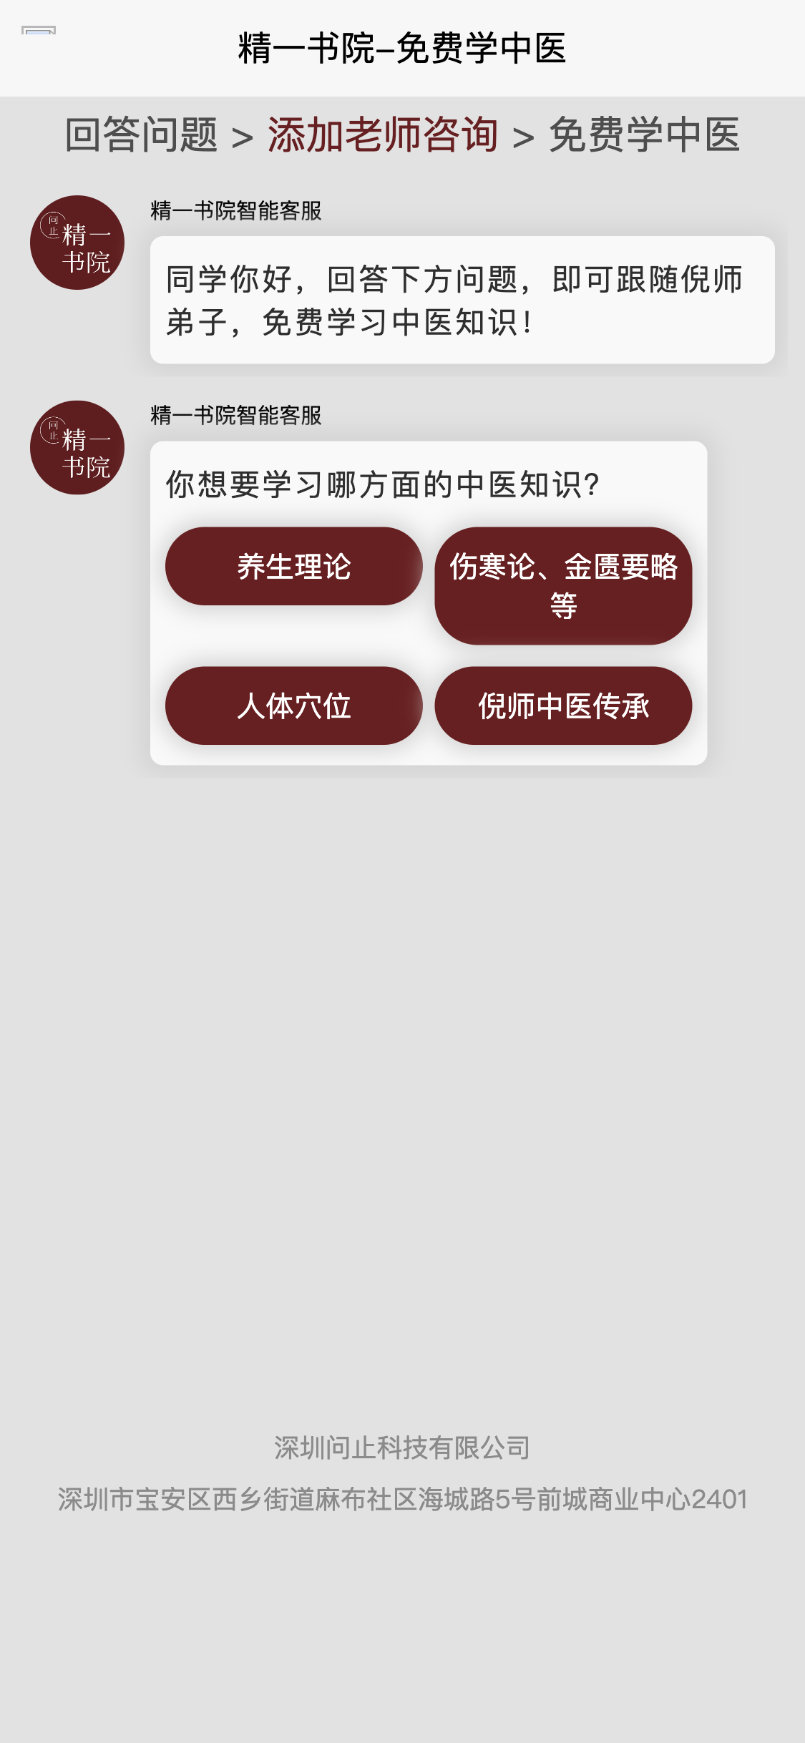

2: https://admin.sdlian.cn/l/iuNuJcYwO3

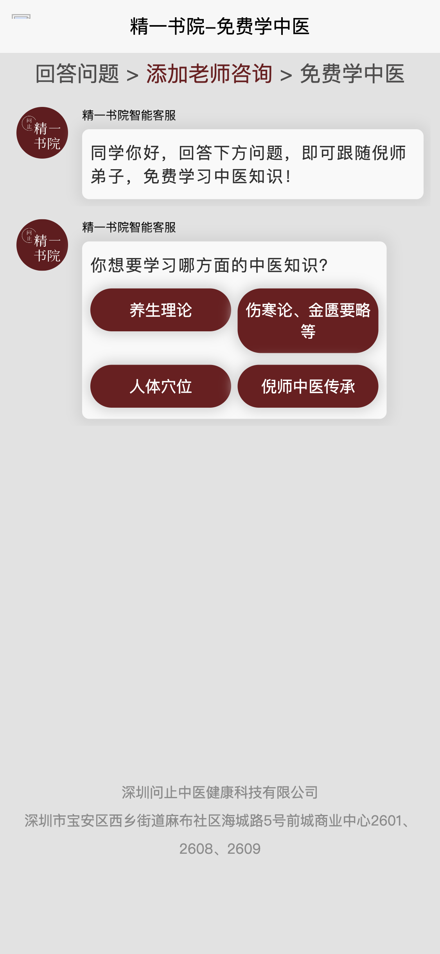

3: https://www.chengzijianzhan.com/tetris/page/7332394489624444978/

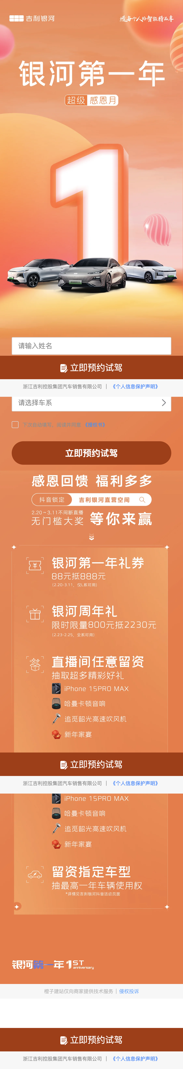

4: https://www.chengzijianzhan.com/tetris/page/7002050685370712071

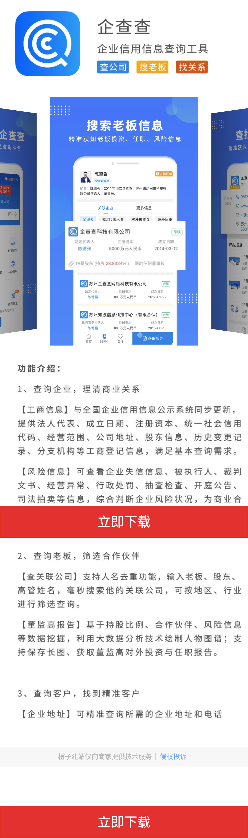

5: https://www.chengzijianzhan.cc/tetris/page/7278943830120235063



6: https://www.chengzijianzhan.com/tetris/page/7184851026884526135

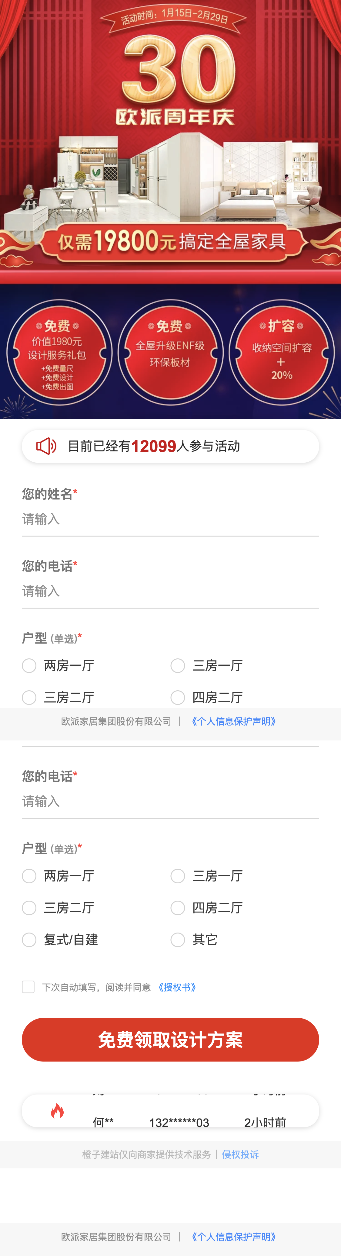

7: https://www.chengzijianzhan.com/tetris/page/7340481851197423666

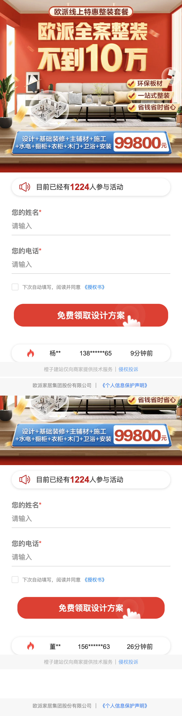

8: https://cid-h5.htat.cc/



9: https://app.yatiku.com/rectLhf3n

